Supplementary Material
Supplementary Tables
Supplementary Table 1. Change of number of OTUs, change of Chao1 index, Bray-Curtis dissimilarity and weighted UniFrac distances between D₀ and D₃ according to treatment groups in the moxifloxacin and clindamycin studies. q-values refer to the comparison of the corresponding treatment group with the antibiotic + DAV131A placebo treatment group, after Benjamini-Hochberg correction. The p-values for the comparison of all treatment groups are reported in the “All groups” line. In the analysis of concentrations, only antibiotic-treated groups were included. Data are presented as n (%) or median (min; max) as appropriate.
Treatment group | n | Change of  number of OTUs | q-value | Change of  Chao-1 index | q-value | Bray-Curtis  dissimilarity | q-value | Weighted UniFrac  distance | q-value
Moxifloxacin
controls | 10 | -5.75 (-97.6; 183.5) | - | -4.1 (-107.0; 190.1) | - | 0.34 (0.28; 0.88) | - | 0.14 (0.08; 0.48) | -
MXF/0 | 10 | -135.85 (-207.3; -52.2) | - | -137.9 (-213.4; -46.2) | - | 0.78 (0.63; 0.86) | - | 0.33 (0.24; 0.48) | -
MXF/200 | 20 | -89.75 (-201; 74.5) | 0.044 | -99.7 (-229.3; 83.5) | 0.091 | 0.70 (0.57; 0.87) | 0.0062 | 0.31 (0.20; 0.57) | 0.53
MXF/300 | 20 | -65.15 (-131.8; 63.8) | 0.0036 | -70.7 (-140.1; 75.0) | 0.0025 | 0.56 (0.35; 0.72) | <10⁻⁴ | 0.24 (0.14; 0.40) | 0.011
MXF/600 | 10 | -65.5 (-129.1; -2.1) | 0.0069 | -66.6 (-141.0; -0.8) | 0.0078 | 0.57 (0.41; 0.72) | 0.00017 | 0.25 (0.15; 0.38) | 0.1
MXF/900 | 10 | -58.05 (-131.5; -7.4) | 0.0056 | -53.2 (-147.3; 6.0) | 0.0091 | 0.47 (0.31; 0.67) | <10⁻⁴ | 0.22 (0.13; 0.36) | 0.011
All groups | 80 | -72.9 (-207.3; 183.5) | <10⁻⁴ | -75.5 (-229.3; 190.1) | <10⁻⁴ | 0.61 (0.28; 0.88) | <10⁻⁸ | 0.26 (0.08; 0.57) | 0.00028
Clindamycin
controls | 9 | 24.7 (-2.1; 62.9) | - | 27.1 (-3.0; 71.9) | - | 0.38 (0.24; 0.45) | - | 0.15 (0.09; 0.24) | -
CLI/0 | 10 | -270.1 (-344.6; -220.0) | - | -274.0; -358.2; -218.7) | - | 0.96 (0.87; 0.98) | - | 0.60 (0.41; 0.62) | -
CLI/300 | 10 | -195.5 (-242.6; -129.1) | 0.00073 | -201.3 (-252.7; -127.8) | 0.0029 | 0.86 (0.71; 0.88) | <10⁻⁴ | 0.41 (0.36; 0.59) | 0.00073
CLI/450 | 10 | -137.1; -227.7; -87.3) | <10⁻⁴ | -137.6 (-236.7; -90.0) | <10⁻⁴ | 0.83 (0.80; 0.85) | <10⁻⁴ | 0.40 (0.35; 0.45) | 0.00016
CLI/600 | 10 | -99.6 (-186.7; -33.6) | <10⁻⁴ | -102.6 (-191.6; -34.3) | <10⁻⁴ | 0.76 (0.66; 0.79) | <10⁻⁴ | 0.30 (0.24; 0.35) | <10⁻⁴
CLI/750 | 10 | -96.1 (-159.1; -22.0) | <10⁻⁴ | -98.1 (-170.6; -22.7) | <10⁻⁴ | 0.70 (0.63; 0.74) | <10⁻⁴ | 0.28 (0.26; 0.39) | <10⁻⁴
CLI/900 | 10 | -107.8 (159.5; -35.1) | <10⁻⁴ | -116.1 (-163.3; -38.7) | <10⁻⁴ | 0.67 (0.61; 0.75) | <10⁻⁴ | 0.30 (0.24; 0.34) | <10⁻⁴
All groups | 69 | -129.1 (-344.6; 62.9) | <10⁻⁸ | -132.8 (-358.2; 71.9) | <10⁻⁸ | 0.75 (0.24; 0.98) | <10⁻¹⁰ | 0.34 (0.09; 0.62) | <10⁻⁹

Supplementary Table 2. Spearman rank correlation coefficient between the fecal concentration of active antibiotic and the change of number of OTUs, the change of Chao1 index, the Bray-Curtis dissimilarity or the weighted UniFrac distances between D₀ and D₃, in antibiotic-treated hamsters of the 2 studies. p-values are presented for the comparison of the Spearman rank correlation coefficient to 0.
Antibiotic | n | Change of number of OTUs | Change of Chao-1 index | Bray-Curtis dissimilarity | Weighted UniFrac  distance
Moxifloxacin | 70 | -0.24 (p=0.052) | -0.25 (p=0.043) | 0.65 (p<10⁻⁸) | 0.46 (p<10⁻⁴)
Clindamycin | 60 | -0.45 (p=0.00035) | -0.43 (p=0.00053) | 0.53 (p<10⁻⁴) | 0.46 (p=0.00018)

Supplementary Figures
Supplementary Figure 1. Mean relative abundance of the main bacterial phyla at D₀ and D₃ in the hamsters treated by antibiotics in the moxifloxacin (top) and clindamycin (bottom) experiments. Stacked bars represent the mean relative abundance of each bacterial phylum.
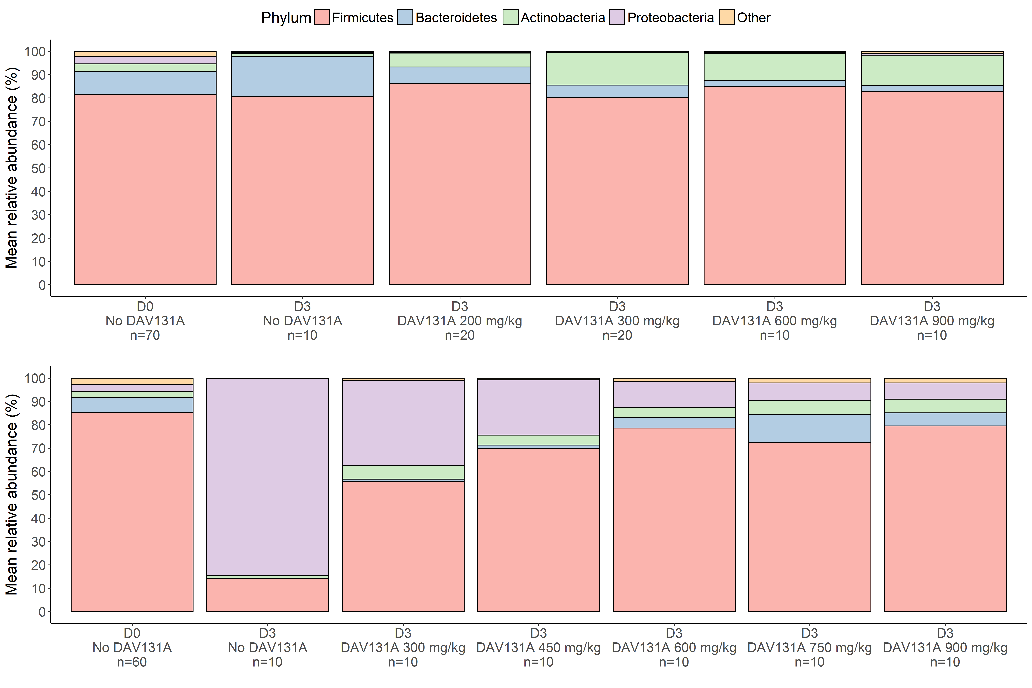
Supplementary Figure 2. Scatterplot of the evolution of the change of Shannon index (top panel) and unweighted UniFrac distance (bottom panel) between D₀ and D₃ according to fecal concentration at D₃ of active moxifloxacin (left) or clindamycin (right). Spearman rank correlation coefficients were -0.25 (p=0.043) and 0.71 (p<10⁻¹⁰) between the concentration of active moxifloxacin and the change of Shannon index or the unweighted UniFrac distance, respectively. Correlation coefficients between the concentration of active clindamycin and the change of Shannon index or the unweighted UniFrac distance were -0.49 (p<10⁻⁴) and 0.57 (p<10⁻⁵), respectively. Black lines correspond to the linear regressions of the diversity index according to the fecal concentration of antibiotic, estimated using the least squares method.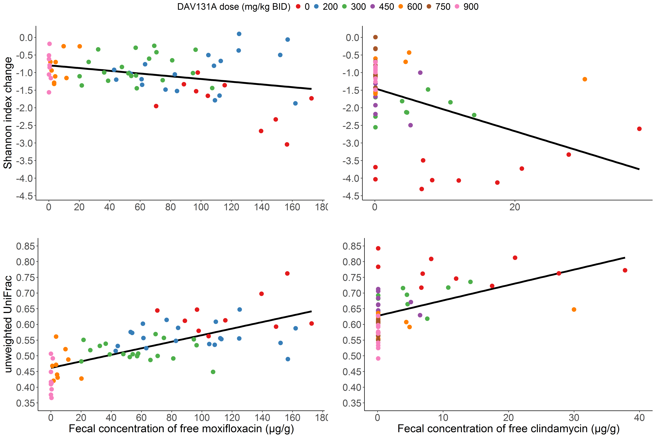

Supplementary Figure 3. Receiving operator curves for the change of Shannon index (red curve) and unweighted UniFrac distance (green curve) between D₀ and D₃ after pooling data from antibiotic-treated animals in the moxifloxacin and clindamycin studies. AUROC for the normalized Shannon index was 0.89 [95%CI, 0.82; 0.95] and AUROC for the unweighted UniFrac distance was 0.95 [95%CI, 0.90; 0.98].
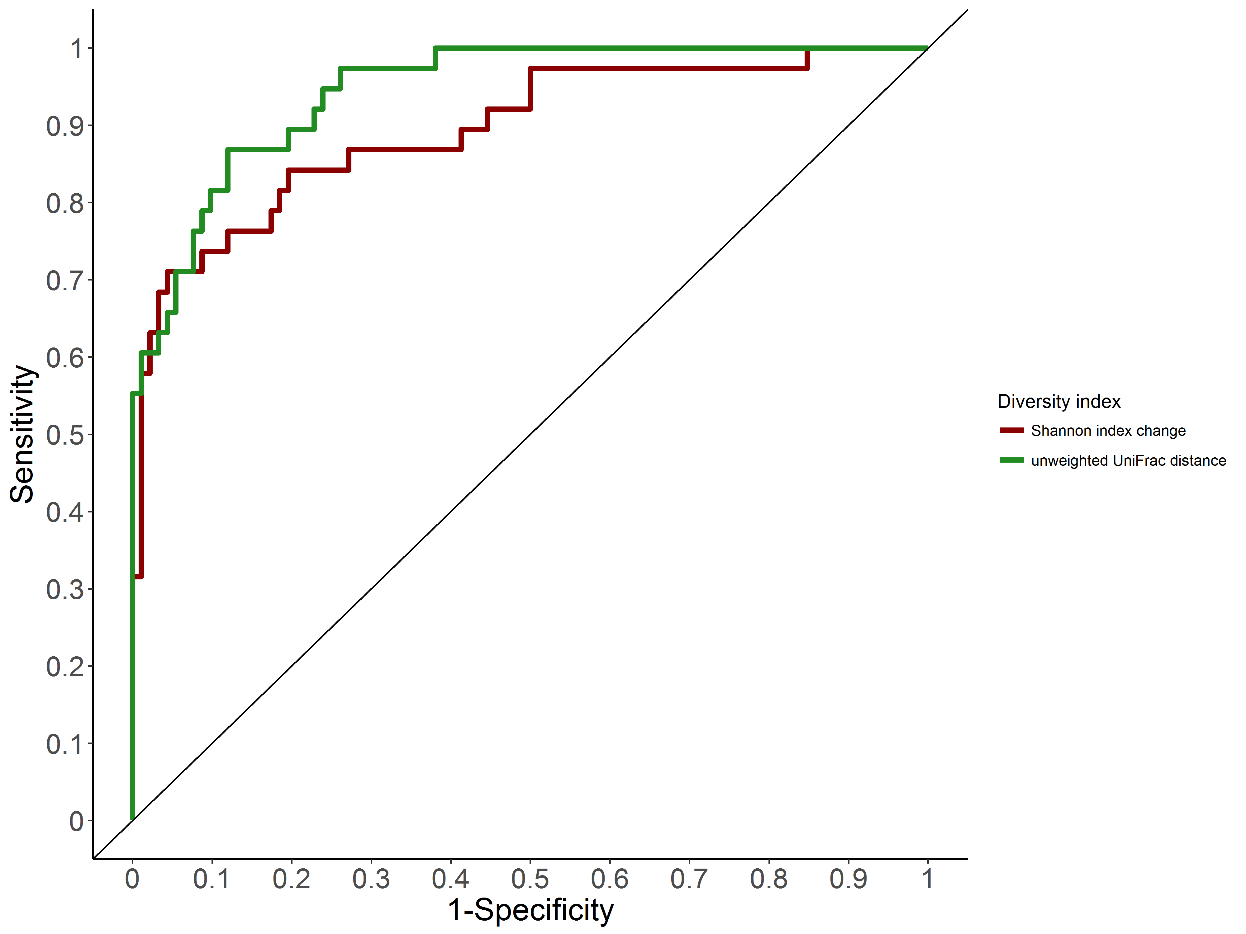

Supplementary Figure 4. Evolution of sensitivity, specificity and Youden index of the normalized change of Shannon index and unweighted UniFrac distance between D₀ and D₃ for prediction of death by D₁₆ according to observed values of both diversity index, after pooling data from antibiotic-treated animals in the moxifloxacin and clindamycin studies. The grey shaded areas represent the 95% confidence intervals of the best cut-off values of both indices.
