Additional file 4
File name: Additional file 4
File format: .pdf
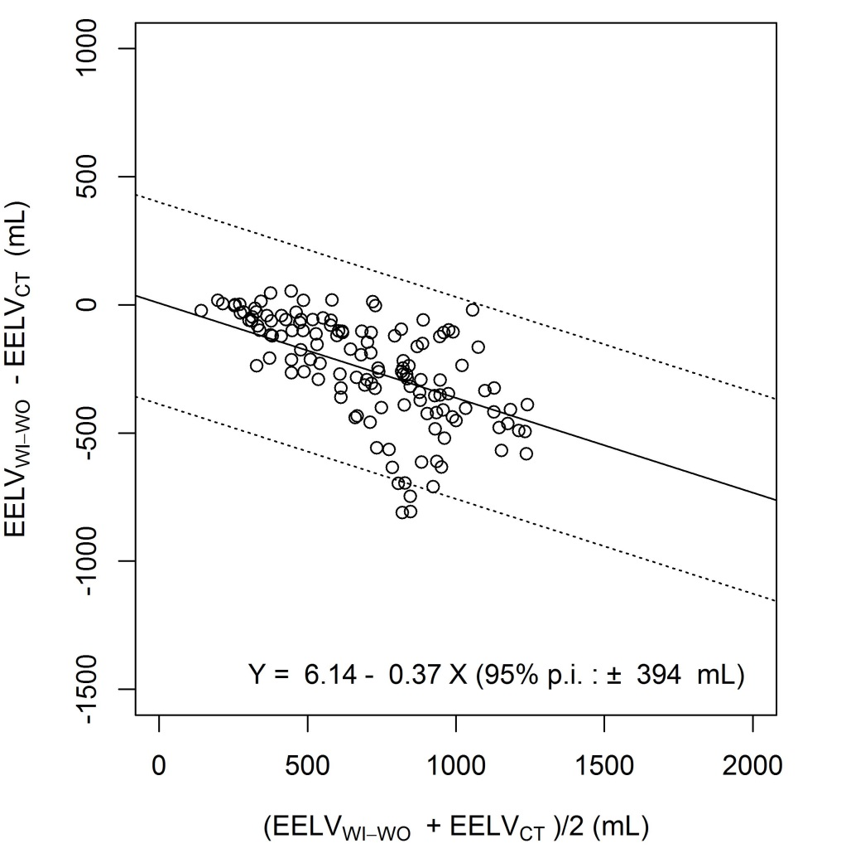
Title of data: Bias and limits of agreement between EELV_{CT} and EELV_{WI-WO}, using Bland and Altman representation in a subset of the data, acquired during the PEEP trial (with 10-minutes between measurements).
Description of data: Each symbol represents a concomitant measurement of EELV_{WI-WO} and EELV_{CT}. Horizontal continuous line and horizontal broken lines are the mean bias and 95% prediction interval limits of the bias between EELV_{WI-WO} and EELV_{CT,} respectively.
EELV_{WI-WO} = end-expiratory lung volume assessed with the nitrogen washout-washin technique; EELV_{CT} = end-expiratory lung volume assessed by computed tomography; 95% p.i. = 95% prediction interval of the bias between EELV_{WI-WO} and EELV_{CT}; V_{T} = tidal volume.

